**Model Architecture**

The structured summary of resumes is fed directly to this model.

The model architecture for evaluating candidates' interpersonal skills is designed to analyze **structured summaries of resumes** and produce an **overall interpersonal skill score**. Here's an overview of the process:

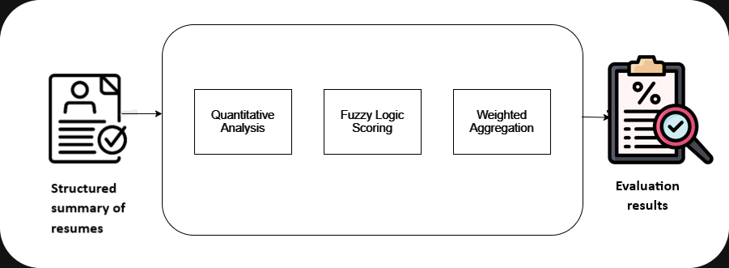

1. **Input**:
   * Structured summary of resumes containing details about skills, projects, leadership roles, and activities.
2. **Model Process**:
   * **Quantitative Analysis**:
     + Count the presence of key interpersonal skills such as communication, leadership, and teamwork.
     + Use NLP methods to map skill occurrences into a matrix, summarizing the candidate's skill profile.
   * **Fuzzy Logic Scoring**:
     + Apply fuzzy logic to assign qualitative scores (e.g., Poor, Moderate, Good, Excellent).
     + Use membership functions to interpret skill counts and provide a flexible, nuanced grading.
   * **Weighted Aggregation**:
     + Combine individual skill scores using category-specific weights.
     + Aggregate the scores to produce an average that forms the overall evaluation.
     + Classify the overall score using fuzzy categories (e.g., "Good (75%)", "Excellent (90%)").
3. **Output**:
   * An overall score that reflects the candidate's interpersonal skill level.
   * The score is presented as a qualitative label and percentage, allowing for quick assessment and comparison.
   * This architecture ensures a thorough analysis that quantifies skill presence, uses flexible grading for better interpretation, and integrates scores meaningfully to reflect overall interpersonal competency.